

Transition Information for Parents/Carers






Preparing for
September 2025

Dear Parent / Guardian,
Here is some important information relating to your child’s transition from Reception to Year One here at Whitestone Infant School.
The aim of this booklet is to clarify some of the main aspects of change your child will encounter moving from Reception to Year One.
We would like to ensure that the transition process is as smooth as possible and that your child’s entry into Year One will be an enjoyable one. We are looking forward to working in partnership with you and your child to help make the experience a positive one.

We hope that you find this information useful.

Regards,

The Year One Team

Transition
The children have had the opportunity to meet their new teacher and teaching assistant and visit their new classroom on induction day. The children have enjoyed mixing with the current Year 1 and Year 2 children at lunch times on the “big playground” and field and they have also joined the rest of the school for assemblies once a week.
Your child’s current teacher and new teacher have met to discuss your child’s academic achievements and progress and have further discussed any relevant information relating to your child.

Year One set up
- Just like Reception, Year 1 has three classes; Class 5, Class 6 and Class 7.
- These classrooms are located at the back of the school building.
- All three classes share the same toilet facilities.
- The year group spends their playtimes on the “big playground” and on the field.

The Year One Team




Mrs St. Denis
Class 5 Teacher

Mrs Hill
Year Lead
Class 7 Teacher
Miss Yeomans
Class 6 Teacher

Teaching Assistants work across the year group providing a variety of support.






Miss Booth
Mrs Fendell
Mrs Murray
Mrs Bennett
Miss Holmes


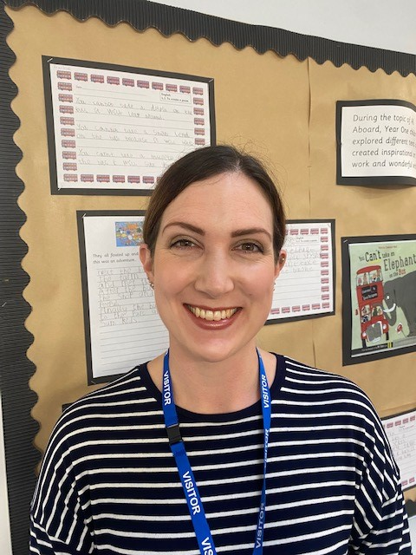


Mrs Mathieson
Mrs Stock
Mrs Dixon

Routines
School times:
All classes have the same start and finish times.
Start: 08:40am
Finish: 03:10pm
- Procedures for the beginning of the day – Children will wait on the playground with an adult until their teacher comes to collect them. Please line up on your child’s class number.
- Procedures for the end of the day – The children will be dismissed from their classroom door. We ask for class 5 parents to stand near the eco-garden, class 6 parents stand to the left of the wooden decking and class 7 parents near the black board. The area for dismal is quite small so we ask for your patience as we dismiss the children safely.

We politely ask for children not to access play equipment outside the classrooms before and after school.

- Drink and Fruit – Children need a named drink bottle to be brought into school each day – they will have access to this all day. This is for water only. Children will still be provided with free fruit but they can bring their own if they want to, please note grapes need to be cut into quarters.

Assemblies
- Children go to assemblies 3x a week from the beginning of the autumn term along with Year 2.
- This will include a weekly theme assembly, singing assembly and celebration assembly. Please send in children’s out of school achievements for celebration assembly.

Home Learning
Home learning is sent out on a Friday. Each week’s home learning will contain mental maths and phonics. There may sometimes be a wider curriculum subject linked to the week’s learning.
Home Learning will be sent out on Teams via an ‘assignment’ set up. More information will follow on this.
We also expect children to read at least three times a week. Generally, they will get two Read Write Inc Books a week and a sharing book.

P.E.
We will continue to allow children to attend school in their PE kits on PE day’s (twice a week). Please make sure during the colder months, children come dressed in a dark (black/navy) coloured tracksuit and trainers. In the warmer months we require them to wear black/navy shorts, a white t-shirt and trainers (not pumps).
Year One’s PE days are: Tuesday and Thursday
(not the first Tuesday and Thursday back)
If they are attending a before/after school sports club they should still wear school uniform during the day and then get changed.
Please ensure that all your child’s belongings are labelled.
Toileting Accidents
Most children will have an accident now and again at school. Please make sure your child brings in a bag, that can be kept on their peg, which contains a change of clothes (this does not have to be uniform). There are plenty of opportunities to go to the toilet during the school day. We encourage them to go at break, lunch and snack time. However, we understand that they may need to go during a lesson. We encourage them not to go during our “carpet times” as this is the point at which the teacher will be doing direct teaching.

Injuries
If children receive an injury in school they will be treated by one of our TA’s who is first aid trained. Your child will receive a “green bump note” which they will bring home with them at the end of the day. For more serious injuries we will phone home.
Independence
It is important that all children learn to become as independent as possible and we would ask your continued support in developing this. Please encourage them to look after their own things and dress themselves as often as possible. Please ensure they have their reading book and diary every day.
We are asking that children bring their belongings in a book bag and not a rucksack. In this way it can be kept in their drawers during the day.

Year One is an exciting time for your child. We look forward to working with them in September. In the new term we will provide further information on day-to-day routines and the curriculum. We hope you all have a good summer and look forward to seeing you in the new term.

Contacting your child’s teacher
- The best way to speak to your child’s teacher is at home time. If this is not possible please contact them via the school office, either by admin2123@welearn365.com or by phone and this will be passed onto your child’s teacher.
- We please ask you to avoid contacting teachers directly via Teams or email.
- If you need accurate up to date information please speak to the school rather than asking on WhatsApp groups.
- Please ensure that you have signed up to parent mail and check the weekly home learning on Teams for upcoming events and notices.

The first day back for children is
Tuesday 2nd September.
Please come along to our Year One information evening on
Tuesday 2nd September
at 6pm

