Whitestone Eco-code
We can help to make Whitestone School a more eco-friendly place by …
Earth Says …
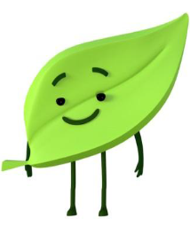

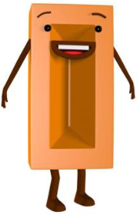
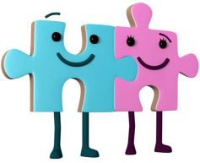

Making sure we stick to the eco-code.
Working together to become more eco-friendly.
Lefty, Righty and Wheel Say … Says …
Finding different ways to travel to school other than the car.
Recycling items such as paper and card.
Making sure animals have a safe place to live in outside areas.
Ensuring taps are fully turned off after use.
Eating fresh and using the fruit caddies and composters.
Switching lights and whiteboards off when not in use.
Puz and Zel Say … Says …
Brick Says …
Crush Says …
Leafy Says …
Tap Says …
Smith Says …
Switch Says …

