
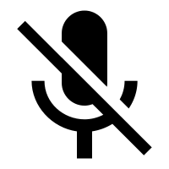



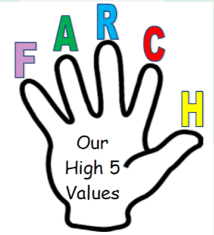


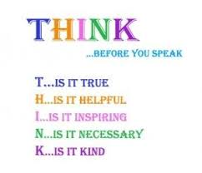
Whitestone’s Video Call Rules!
Before joining you must:

- Make sure you are dressed appropriately. No pyjamas!

- Sit in a quiet space at a table showing the Whitestone way of sitting.

- Check your background.

- Make sure you can see all of your face on the camera.

- Mute your microphone! If you would like to speak use the hand signal.

During the call you must:

- Behave appropriately. Think of our high 5 values!

- Only use the chat if the adult asks you to.

- Do not put any emojis/GIFs into the chat.

- Communicate with adults appropriately.

